FitTrack AI
Backend System Documentation

Project: FitTrack AI – Backend System

Prepared by:
KESHAUVARDHANAN J [TEAM LEADER]
BALAMURUGAN U V
DEEPAK C
DEEPAK M
KUMARAN D

Node.js • Express.js • MongoDB • Mongoose • Google Gemini AI

Table of Contents

- 1. Introduction 3
- 2. Objectives 3
- 3. System Requirements 3
- 4. Architecture Overview 4
- 5. Components 4
- 6. Entity Relationship Model 6
- 7. Key Features 7
- 8. Project Setup 7
- 9. Database Configuration 8
- 10. API Endpoints 8
- 11. Testing 9
- 12. Outcome & Future 10
Enhancements

1. Introduction
FitTrack AI is a secure, scalable backend application designed to simplify workout tracking and deliver personalized, AI-driven fitness recommendations. It combines a robust REST API with Google Gemini AI to help users log workouts, understand their progress, and receive tailored guidance without relying on manual spreadsheets or generic fitness plans.
The system is built on a modern JavaScript stack — Node.js, Express.js, MongoDB, and Mongoose — chosen for its non-blocking I/O model, mature ecosystem, and flexibility when working with evolving fitness data schemas. The backend follows a layered, modular architecture (routes → controllers → services → database) so that each concern can be developed, tested, and scaled independently.
This document describes the system's objectives, architecture, data model, features, setup process, API surface, and testing strategy, and outlines a roadmap for future enhancements.
2. Objectives
The core objectives guiding the design of FitTrack AI's backend are:
- Centralized workout tracking — a single source of truth for every logged workout, searchable by name, category, or date.
- Secure authentication — protect user data and API access using industry-standard JSON Web Tokens (JWT) and salted password hashing.
- AI-powered recommendations — leverage Google Gemini AI to generate personalized workout plans, tips, and safety guidance.
- Fitness insights generation — analyze historical workout data to surface performance trends and motivational feedback.
- Scalable modular architecture — a clean separation of routes, controllers, services, and data layers that supports future growth without major rewrites.
3. System Requirements
3.1 Software Requirements
Component | Requirement
Runtime | Node.js v16 or later
Package Manager | npm v8 or later
Web Framework | Express.js
Database | MongoDB (local or Atlas cluster)
ODM | Mongoose
API Testing | Postman or Thunder Client
IDE | Visual Studio Code

3.2 Hardware Requirements
Component | Minimum Specification
Processor | Intel i5 / AMD Ryzen 5 or equivalent
Memory (RAM) | 8 GB minimum
Storage | 1 GB free disk space
4. Architecture Overview
FitTrack AI follows a request-driven, layered architecture. Every incoming request passes through the Express server, is authenticated by JWT middleware where required, and is then routed to the appropriate controller. Controllers delegate business logic to services, which in turn communicate with MongoDB for persistence and with the Gemini AI service for generating recommendations and insights.
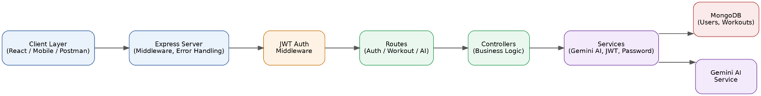
Figure 1 — Backend Architecture Flow
Key architectural principles:
- JWT middleware protects sensitive routes before any controller logic executes, ensuring unauthorized requests are rejected early.
- Each layer has a single, well-defined responsibility — routes handle HTTP wiring, controllers handle request/response logic, and services encapsulate business rules and external integrations.
- The AI service is isolated from the core CRUD logic, so the Gemini integration can evolve or be swapped without affecting workout management.
5. Components
5.1 Client Layer
Represents any consumer of the API — a React web application, a mobile client, or a tool such as Postman used during development and testing. The client layer is responsible only for presentation and for issuing authenticated HTTP requests.
5.2 Express Server
The entry point for all HTTP traffic. It configures global middleware (JSON body parsing, CORS, logging) and centralized error handling, ensuring that failures anywhere in the stack return consistent, well-formed error responses.
5.3 Authentication Middleware
Validates the JWT supplied in the Authorization header on protected routes, attaches the authenticated user's identity to the request object, and rejects requests with missing, expired, or malformed tokens.
5.4 Routes
Defines the API surface, grouped by domain: Authentication routes, Workout routes, and AI routes. Each route maps an HTTP method and path to a controller function.
5.5 Controllers
Contain the request-handling logic: validating input, invoking the relevant service, and shaping the HTTP response. Controllers remain thin, pushing complex logic down into services.
5.6 Services
Encapsulate business logic and third-party integrations, including the Gemini AI service (recommendations and insights), the JWT service (token issuance and verification), and the password service (hashing and comparison via bcrypt).
5.7 Database Layer
MongoDB collections — Users and Workouts — accessed through Mongoose schemas that enforce validation rules and define relationships between entities.
6. Entity Relationship Model
FitTrack AI's data model centers on two collections: Users and Workouts. Each user can log many workouts, while every workout belongs to exactly one user — a one-to-many relationship enforced at the application level via the UserID foreign key stored on each workout document.
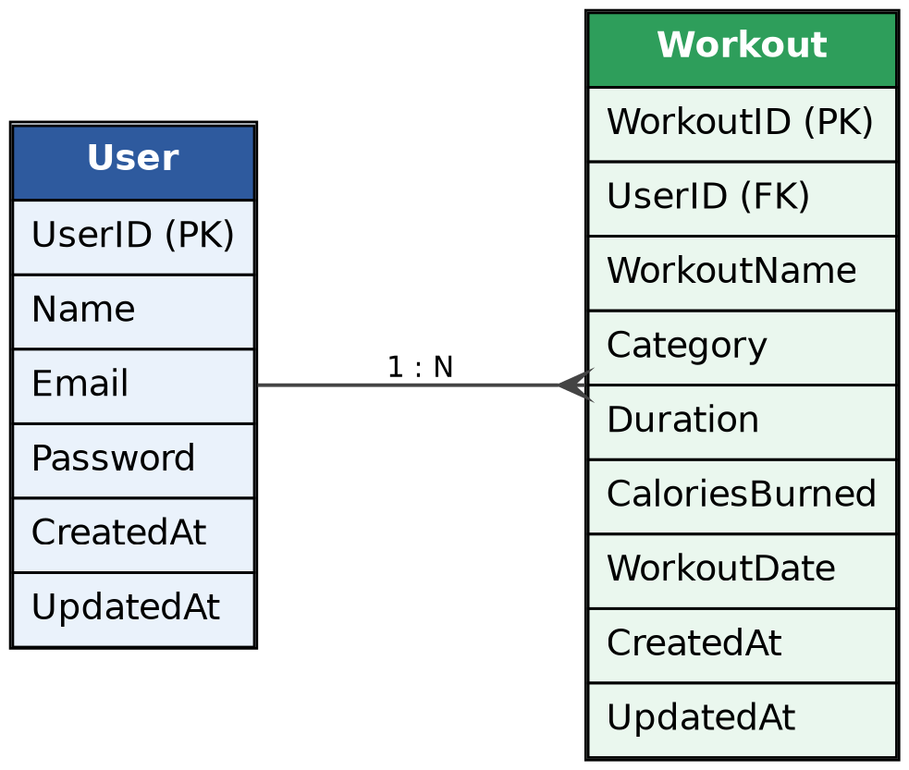
Figure 2 — Entity Relationship Diagram (User → Workout)
6.1 User Entity
Field | Description
UserID | Primary key; unique identifier for the user
Name | Full name of the user
Email | Unique email address, used for login
Password | Hashed password (bcrypt)
CreatedAt | Timestamp the account was created
UpdatedAt | Timestamp of the last profile update

6.2 Workout Entity
Field | Description
WorkoutID | Primary key; unique identifier for the workout
UserID | Foreign key referencing the owning User
WorkoutName | Name or label of the workout
Category | Workout type, e.g. Cardio, Strength, Yoga
Duration | Length of the workout, in minutes
CaloriesBurned | Estimated calories burned during the session
WorkoutDate | Date the workout was performed
CreatedAt | Timestamp the record was created
UpdatedAt | Timestamp of the last record update

6.3 Relationship Summary
- One User → Many Workouts (1:N).
- Deleting a user's account should cascade to (or soft-delete) their associated workout records to avoid orphaned data.
- Indexes on UserID, and on the (UserID, WorkoutDate) pair, keep search and history queries fast as workout volume grows.
7. Key Features
- Secure JWT-based authentication for registration, login, and profile access.
- Full CRUD workout management — create, read, update, and delete workout records.
- Flexible search — filter workouts by name, category, or date range.
- AI-generated recommendations — personalized workout plans, form tips, and safety guidance from Gemini AI.
- AI-generated insights — performance analysis and motivational feedback based on logged history.
- Centralized error handling — consistent, predictable error responses across all endpoints.
- RESTful API design — predictable resource-based URLs and standard HTTP verbs.
8. Project Setup
Follow these steps to set up the FitTrack AI backend in a local development environment:
1. Create the project folder
Create a new directory for the project and navigate into it from the terminal.
2. Initialize the Node.js project
Run npm init -y to generate a default package.json file.
3. Install dependencies
Install the core dependencies: express, mongoose, bcryptjs, jsonwebtoken, and cors, along with any additional packages needed for the Gemini AI integration.
4. Configure environment variables
Create a .env file containing values such as PORT, MONGODB_URI, JWT_SECRET, and the Gemini API key. Never commit this file to version control.
5. Start the server
Run npm start (or a configured dev script using nodemon) to launch the Express server.
9. Database Configuration
MongoDB stores application data in two primary collections: Users and Workouts. Mongoose schemas define the shape of each document, enforce validation rules (required fields, data types, unique constraints), and provide a consistent interface for querying and updating data.
The database connection is centralized in a single configuration module (config/db.js), which is responsible for establishing the connection at startup, handling connection errors gracefully, and exposing the connection instance to the rest of the application.
- Users collection — stores account credentials and profile information.
- Workouts collection — stores individual workout records linked to a user via UserID.
- Mongoose schema validation ensures data integrity before documents are persisted.
- A centralized connection module avoids duplicated connection logic across the codebase.
10. API Endpoints
10.1 Authentication
Method | Endpoint | Description
POST | /api/auth/register | Register a new user account
POST | /api/auth/login | Authenticate a user and issue a JWT
GET | /api/auth/profile | Retrieve the authenticated user's profile

10.2 Workouts
Method | Endpoint | Description
POST | /api/workouts | Add a new workout record
GET | /api/workouts | Retrieve all workouts for the authenticated user
GET | /api/workouts/search | Search workouts by name, category, or date
PUT | /api/workouts/:id | Update an existing workout record
DELETE | /api/workouts/:id | Delete a workout record

10.3 AI
Method | Endpoint | Description
POST | /api/ai/recommendations | Generate a personalized workout plan and tips
GET | /api/ai/insights | Generate performance insights from workout history
11. Testing
API testing is performed using Postman or Thunder Client, with requests organized into collections that mirror the route groups defined in the application.
Endpoints should be tested in the following order to respect functional dependencies:
- 1. Authentication endpoints — verify registration and login succeed, and that a valid JWT is returned.
- 2. Workout endpoints — using the JWT from step 1, verify CRUD and search operations behave correctly and enforce ownership (a user cannot access another user's workouts).
- 3. AI endpoints — verify recommendations and insights are generated correctly from existing workout data.
Additional testing considerations include validating error responses for invalid input, expired tokens, and missing required fields, as well as basic load testing of frequently used endpoints.
12. Outcome & Future Enhancements
12.1 Outcome
- Eliminates manual, spreadsheet-based workout tracking.
- Provides secure, AI-driven fitness guidance tailored to each user's history.
- Establishes a modular, maintainable backend foundation that can support additional features without significant rework.
12.2 Future Enhancements
- Nutrition tracking — log meals and macronutrient intake alongside workouts.
- BMI calculation — derive and track body mass index over time.
- Wearable device integration — sync data from fitness trackers and smartwatches.
- Reminders and notifications — prompt users to log workouts or follow AI-recommended plans.
- Analytics dashboards — visualize long-term trends in performance, consistency, and progress.

